2023
Conference T-Shirt Order Form
Orders due on June 1st
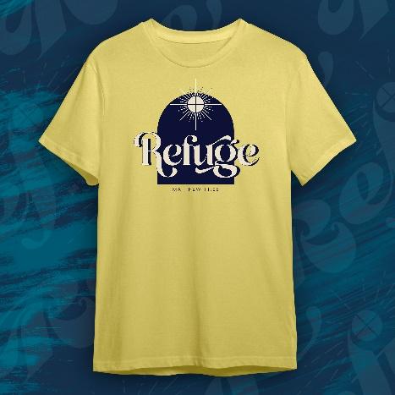
Front Design:
Back Design will list the conference locations and dates

Group Name: Click or tap here to enter text.
Group Leader: Click or tap here to enter text.
Week Attending: Choose an item.
Size | Number | Cost Per: | Total
Small | Click or tap here to enter text. | 15.00 | Click or tap here to enter text.
Medium | Click or tap here to enter text. | 15.00 | Click or tap here to enter text.
Large | Click or tap here to enter text. | 15.00 | Click or tap here to enter text.
X-Large | Click or tap here to enter text. | 15.00 | Click or tap here to enter text.
XX-Large | Click or tap here to enter text. | 18.00 | Click or tap here to enter text.
Total: Click or tap here to enter text.
Please send completed orders with payment to:
Office of Youth Ministry
20 Archbishop May Dr.
St. Louis, MO 63119
Or email melissaboesch@archstl.org

Check or ACH Payment preferred. Please email Melissa if you need an invoice.

Credit Card: Click or tap here to enter text. Exp. Date: Click or tap here to enter text.
Security Code: Click or tap here to enter text. Billing Zip Code: Click or tap here to enter text.

